PRT2 TERM2_INDIVIDUAL ASSIGNMENT

ameer ismail - GROUP 19

218216033

2021

LOGIN PAGE

(AMEER ISMAIL)

Reflection

**My role:**

As a team member of project 2 group 19, I was assigned to create a login page for the agreed upon android application (load shedding app for students).

Thus far, I have completed the design of the specific application login page and managing to complete the functionality of it to do its purpose and navigate.

The design was pretty simple and straightforward so that each student finds it pleasing and informal to work.

However, functionality was challenging but with patience comes success.

* The basic function of the login page is to login to the application using your personal/ student email and your selective password in order to retrieve the data.
* Thereafter, within the login page are:
  + Forgot password (navigates to the Reset page)
  + Sign up (navigates to the registration page)

**WIREFRAME OF THE LOGIN PAGE**

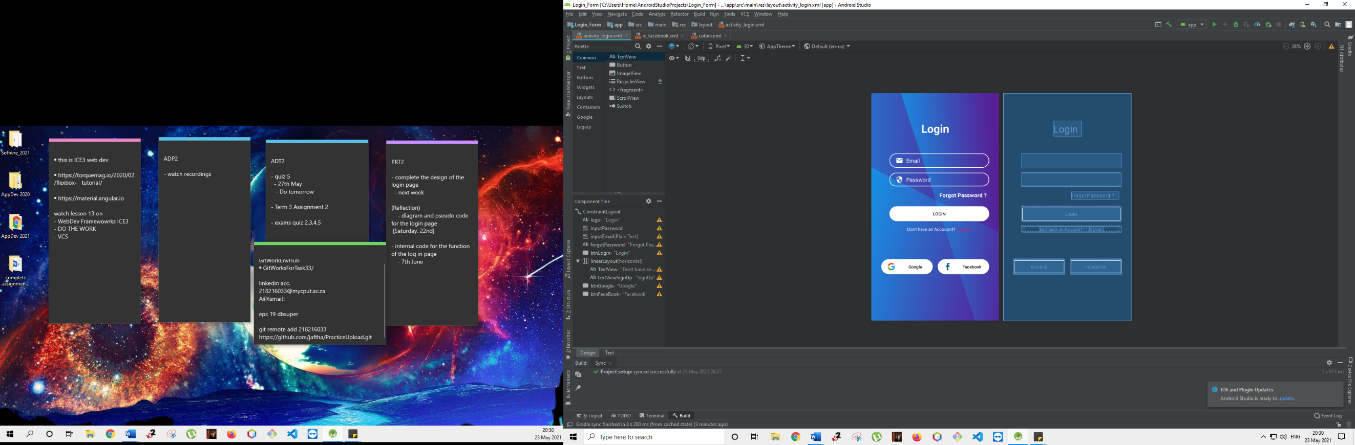

**DIAGRAM**

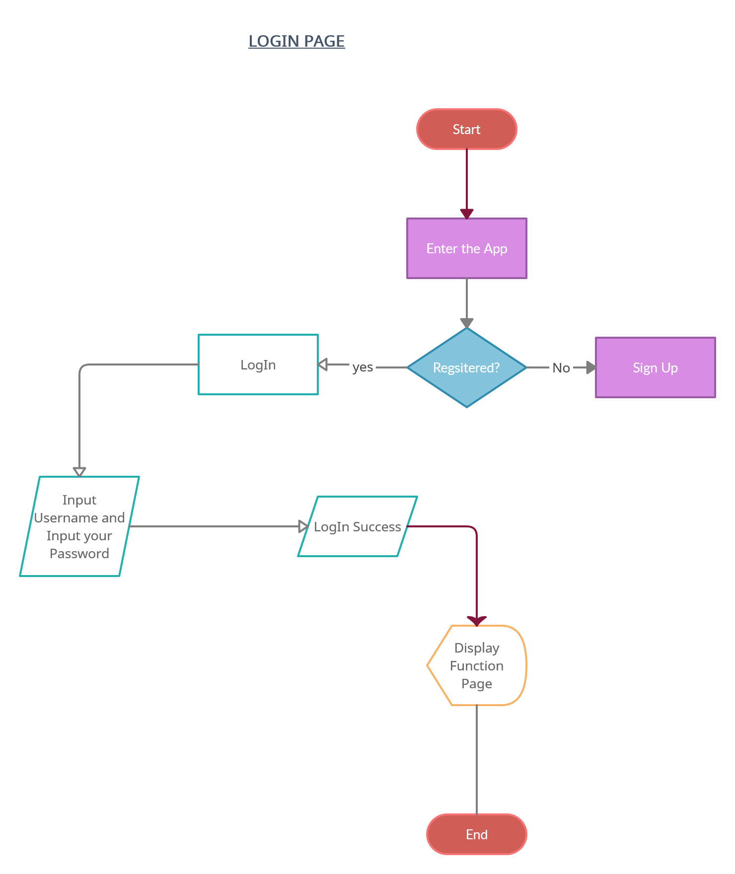

**Login page steps / Pseudo Code**

**Start**

* **Input**
  + Student Email
  + Password
* **If unsuccessful – register/ Sign Up**
  + Register page
* **If successful**
  + Login
* Display function Page
* **If a Registered User and fail to Login**
  + Forgot Password
* Display Reset Page

**End**

**Display output of the Login page**

